IT 230 Module Two Coding Activity Instructions

Adding and Multiplying Four Integers (AddMultiplyFourInts)

Overview
In your Module Two Coding Discussion, you used Console and Convert classes to convert number values. In this activity, you will apply what you have learned to write a program that adds and multiplies four integers.

Directions
Before you begin, complete the following tasks:

- Review the module resources for information to help you complete this activity.
- Download the Coding Activity Submission Template linked in the Coding Activity Guidelines and Rubric. Rename the file using the following naming convention:

Lastname_firstname_addmultiplyfourints.docx

Then use the following steps to complete this activity:

- Write a program called AddMultiplyFourInts that creates four integer variables and initializes them to 13, 55, 123, and 325. Write the program to output both the sum and the product of these four numbers.

Your program output should look like this sample output:

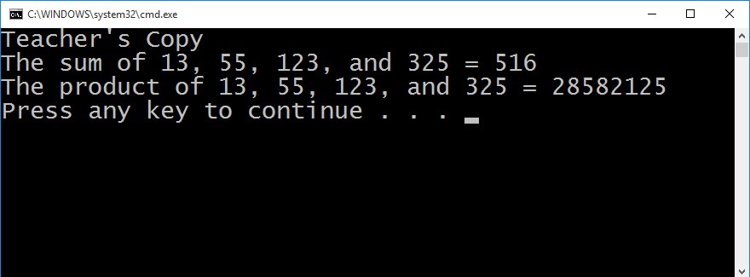

- Make a ZIP file containing all of your Visual Studio project files and source code that can be loaded and run in Visual Studio on a separate computer.
- Complete the Coding Activity Submission Template in which you:
  - Provide a screenshot of your program output that shows the program is fully functioning and data results are accurate for the given problem.
  - Provide the text of the source code you wrote to complete the activity.
    - Your code should meet the style and structure requirements noted in the Coding Activity Guidelines and Rubric. Copy and paste the text from the *.cs file into the document.
  - Provide an explanation of the process and steps you took to complete the project and arrive at a solution that demonstrates the successful completion of the activity.
  - Include a reflection on your learning experience and what you learned from completing the activity.
- Submit your completed coding activity template and ZIP file for grading and feedback.

For details on how this activity will be graded, refer to the Coding Activity Guidelines and Rubric linked in the prompt for this assignment in Module Two.

